1. If a file cannot be opened, the associated code does not show up in the composer section. 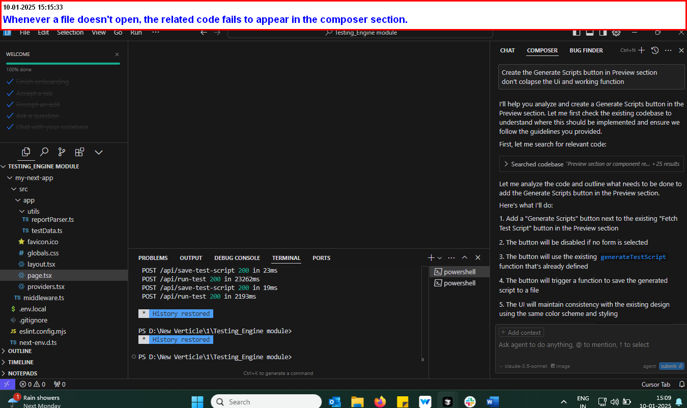
2. I configured a Cursor rule to prevent the creation of the 'my-next-app' and 'SRC' folder, but it isn't working.